CC- Product Inventory Management System Develop an application in Salesforce using the Apex programming language and visual force page to manage Product Inventory records (Product Name, Serial No, Manufacture Date, Expiry Date) stored in a custom object.
Product
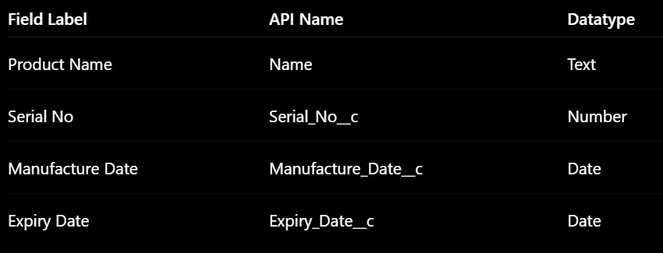

Apex

public class ProductInventoryController {

public Product__c product {get; set;}

public List<Product__c> productList {get; set;}

public Id deleteId {get; set;}

public Id editId {get; set;}

// Constructor

public ProductInventoryController() {

product = new Product__c();

loadProducts();

}

// Load products

public void loadProducts() {

productList = [

SELECT Id,

Name,

Serial_No__c,

Manufacture_Date__c,

Expiry_Date__c

FROM Product__c

ORDER BY Serial_No__c

];

}

// Save OR Update product

public void saveProduct() {

try {

// UPDATE

if(product.Id != null) {

update product;

ApexPages.addMessage(

new ApexPages.Message(

ApexPages.Severity.CONFIRM,

'Product Record Updated Successfully'

)

);

}

// INSERT

else {

insert product;

ApexPages.addMessage(

new ApexPages.Message(

ApexPages.Severity.CONFIRM,

'Product Record Saved Successfully'

)

);

}

// Reset form

product = new Product__c();

loadProducts();

}

catch(Exception e) {

ApexPages.addMessage(

new ApexPages.Message(

ApexPages.Severity.ERROR,

e.getMessage()

)

);

}

}

// Edit product

public void editProduct() {

try {

product = [

SELECT Id,

Name,

Serial_No__c,

Manufacture_Date__c,

Expiry_Date__c

FROM Product__c

WHERE Id = :editId

];

ApexPages.addMessage(

new ApexPages.Message(

ApexPages.Severity.INFO,

'Edit Product Details'

)

);

}

catch(Exception e) {

ApexPages.addMessage(

new ApexPages.Message(

ApexPages.Severity.ERROR,

e.getMessage()

)

);

}

}

// Delete product

public void deleteProduct() {

try {

delete [

SELECT Id

FROM Product__c

WHERE Id = :deleteId

];

ApexPages.addMessage(

new ApexPages.Message(

ApexPages.Severity.CONFIRM,

'Product Record Deleted Successfully'

)

);

loadProducts();

}

catch(Exception e) {

ApexPages.addMessage(

new ApexPages.Message(

ApexPages.Severity.ERROR,

e.getMessage()

)

);

}

}

}

VFP
<apex:page controller="ProductInventoryController">

<apex:form>

<apex:pageBlock title="Product Inventory Management System" id="productForm">

<apex:pageBlockSection title="Add Product Record"
columns="2">

<apex:inputField value="{!product.Name}" />

<apex:inputField value="{!product.Serial_No__c}" />

<apex:inputField value="{!product.Manufacture_Date__c}" />

<apex:inputField value="{!product.Expiry_Date__c}" />

</apex:pageBlockSection>

<apex:commandButton value="Save Product"
action="{!saveProduct}"
rerender="productTable,bottomMsg,productForm"/>

</apex:pageBlock>

<br/>

<apex:pageBlock title="Product Inventory Records"
id="productTable">

<apex:pageBlockTable value="{!productList}"
var="p">

<apex:column value="{!p.Name}" />
<apex:column value="{!p.Serial_No__c}" />
<apex:column value="{!p.Manufacture_Date__c}" />
<apex:column value="{!p.Expiry_Date__c}" />

<apex:column headerValue="Action">

<!-- Edit Button -->
<apex:commandButton value="Edit"
action="{!editProduct}"
rerender="productForm,topMsg,bottomMsg,productTable">

<apex:param name="eid"
value="{!p.Id}"
assignTo="{!editId}" />

</apex:commandButton>

&nbsp;

<!-- Delete Button -->
<apex:commandButton value="Delete"
action="{!deleteProduct}"
rerender="productForm,topMsg,bottomMsg,productTable">

<apex:param name="pid"
value="{!p.Id}"
assignTo="{!deleteId}" />

</apex:commandButton>

</apex:column>

</apex:pageBlockTable>

</apex:pageBlock>

<!-- Bottom Messages -->
<apex:pageMessages id="bottomMsg"/>

</apex:form>

</apex:page>

CC- Student Record Management System Develop an application in Salesforce using the Apex programming language and visual force page to manage student records (Name, Roll No, Class, Mobile No)stored in a custom object
Student
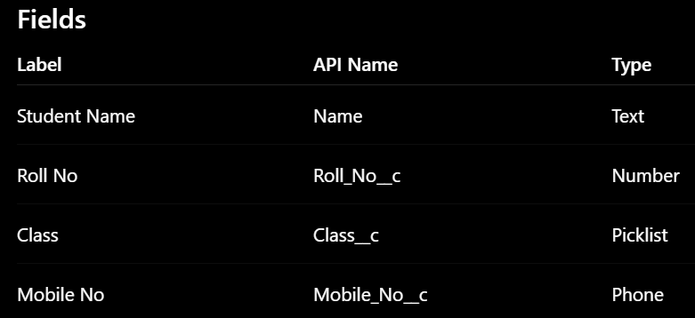
Class = FE,SE,TE,BE

Apex

public class StudentControllrt {

public Student__c std {get; set;}

public List<Student__c> stdList {get; set;}

public Id deleteId {get; set;}

public Id editId {get; set;}

public StudentControllrt(){

std = new Student__c();

loadStudents();

}

public void loadStudents(){

stdList = [

SELECT Id, Name, Roll_no__c, Mobile_no__c, Class__c FROM Student__c ORDER BY Roll_no__c

];

}

public void saveStd(){

try {

if (std.Id != null){

update std;

ApexPages.addMessage(new ApexPages.Message(

ApexPages.Severity.CONFIRM, 'Student updated'

));

} else {

insert std;

ApexPages.addMessage(new ApexPages.Message(

ApexPages.Severity.CONFIRM, 'Student added'));

}

std = new Student__c();

loadStudents();

} catch (Exception e){

ApexPages.addMessage( new ApexPages.Message(

ApexPages.Severity.ERROR, e.getMessage()));

}

}

public void editStd(){

try{

std = [SELECT Id, Name, Roll_no__c, Mobile_no__c, Class__c FROM Student__c WHERE Id = :editId];

ApexPages.addMessage(

new ApexPages.Message(

ApexPages.Severity.INFO,

'Edit Product Details'

)

);

} catch (Exception e){

ApexPages.addMessage(

new ApexPages.Message(

ApexPages.Severity.ERROR,

e.getMessage()

)

);

}

}

public void deleteStd(){

try{

delete [SELECT Id FROM Student__c WHERE Id = :deleteId];

loadStudents();

ApexPages.addMessage(

new ApexPages.Message(

ApexPages.Severity.CONFIRM,

'Student deleted'

)

);

} catch (Exception e){

ApexPages.addMessage(

new ApexPages.Message(

ApexPages.Severity.ERROR,

e.getMessage()

)

);

}

}

}

VFP
<apex:page controller="StudentControllrt">
<apex:form>
<apex:pageBlock title="Student Mgmt Sys" id="stdForm">
<apex:pageBlockSection title="Add Student" columns="2">
<apex:inputField value="{!std.Name}"/>
<apex:inputField value="{!std.Roll_no__c}"/>
<apex:inputField value="{!std.Class__c}"/>
<apex:inputField value="{!std.Mobile_no__c}"/>
</apex:pageBlockSection>
<apex:commandButton value="Save" action="{!saveStd}" rerender="stdForm,msg,stdTable"/>
</apex:pageBlock>
<br/>
<apex:pageBlock title="Student Records" id="stdTable">
<apex:pageBlockTable value="{!stdList}" var="s">
<apex:column value="{!s.Name}"/>
<apex:column value="{!s.Roll_no__c}"/>
<apex:column value="{!s.Class__c}"/>
<apex:column value="{!s.Mobile_no__c}"/>
<apex:column headerValue="Actions">
<apex:commandButton value="Edit" action="{!editStd}" rerender="stdForm,msg,stdTable">
<apex:param name="eid" value="{!s.Id}" assignTo="{!editId}"/>
</apex:commandButton>
<apex:commandButton value="Delete" action="{!deleteStd}" rerender="stdForm,stdTable,msg">
<apex:param name="did" value="{!s.Id}" assignTo="{!deleteId}" />
</apex:commandButton>

</apex:column>
</apex:pageBlockTable>
</apex:pageBlock>

<apex:pageMessages id="msg"/>

</apex:form>

</apex:page>

